**Teaching Notes: Modular Design and Code Organization**

**1. Modular Design Principles: Cohesion and Coupling**

**1.1 What is Modular Design?**

Modular design refers to breaking a software system into **independent, reusable components** (modules) that work together. Each module focuses on a specific function, improving maintainability, scalability, and ease of debugging.

**1.2 Cohesion**

**Definition:** Cohesion refers to how closely related the responsibilities of a module are. High cohesion means a module has a **single, well-defined purpose**.

**Types of Cohesion:**

1. **Coincidental Cohesion** – Randomly grouped functionalities (worst case).
2. **Logical Cohesion** – Grouped by category, not function (e.g., utility functions).
3. **Temporal Cohesion** – Grouped because they execute at the same time (e.g., logging functions).
4. **Procedural Cohesion** – Functions that execute sequentially but may serve different purposes.
5. **Functional Cohesion** – Every part of the module contributes to a single, well-defined task (best practice).

**Example of High Cohesion (React Component)**

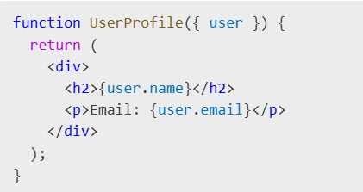

Here, the **UserProfile** component only displays user data, ensuring high cohesion.

**1.3 Coupling**

**Definition:** Coupling measures how dependent modules are on each other. **Low coupling is desirable**, as it reduces inter-dependencies, making code easier to maintain and test.

**Types of Coupling:**

1. **Content Coupling (Worst)** – One module modifies another’s internal data.
2. **Common Coupling** – Modules share global variables.
3. **Control Coupling** – One module controls the logic of another.
4. **Data Coupling** – Modules communicate only through well-defined data (best practice).
5. **Message Coupling** – Modules communicate through APIs without sharing data (ideal scenario).

**Example of Low Coupling (Backend Service Calls in React)**

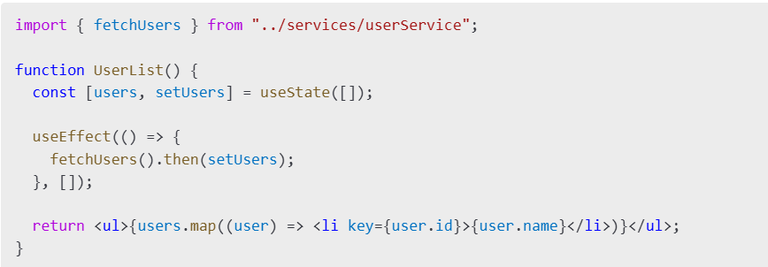

Here, **UserList** does not depend on implementation details of fetching users—it only calls the function, reducing coupling.

**2. Layered Architecture (Frontend, Backend, Database)**

**2.1 What is Layered Architecture?**

Layered architecture organizes code into different layers, each responsible for specific functionality. This improves **scalability, security, and maintainability**.

**Standard Layers:**

1. **Presentation Layer (Frontend)** – User interface, UI logic.
2. **Application Layer (Backend Services)** – Business logic, processing.
3. **Data Layer (Database)** – Data storage, retrieval.

**2.2 Frontend Layer (React)**

Handles user interactions and UI rendering.

* **Technologies:** React, Vue.js, Angular.
* **Best Practices:**
  + Use component-based architecture.
  + Separate UI logic from business logic.
  + Use state management (Redux, Context API).

**Example: Separate API Calls from UI**

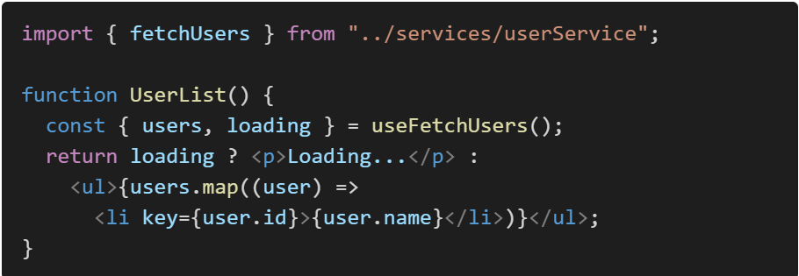

**2.3 Backend Layer (Node.js, Django)**

Handles business logic, request processing, and interacts with the database.

* **Technologies:** Node.js (Express), Django, Spring Boot.
* **Best Practices:**
  + Separate concerns (controllers, services, repositories).
  + Implement authentication and authorization.
  + Use caching and performance optimizations.

**Example: Backend API Route (Express.js)**

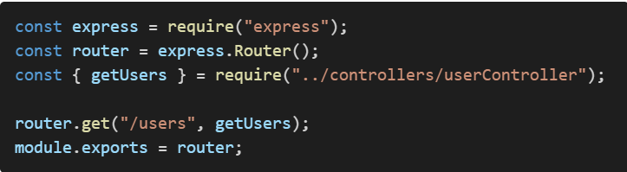

**2.4 Database Layer (MySQL, MongoDB)**

Stores and retrieves application data.

* **Technologies:** MySQL, PostgreSQL, MongoDB.
* **Best Practices:**
  + Normalize relational databases.
  + Use indexing for performance.
  + Store environment variables securely.

**Example: User Schema (MongoDB, Mongoose)**

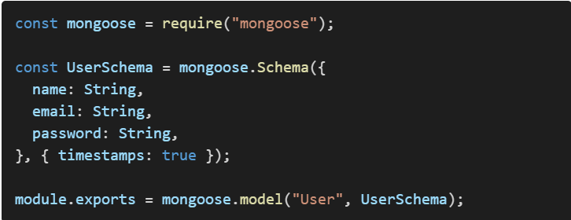

**3. Code Organization for Scalability and Maintainability**

**3.1 Importance of Code Organization**

Good code organization ensures:

✅ **Scalability** – Adding new features is easier.

✅ **Maintainability** – Code is easier to understand and debug.

✅ **Reusability** – Components and functions can be reused across the application.

**3.2 Recommended Project Structure (React + Node.js)**

project-root/

│── frontend/

│ ├── src/

│ │ ├── components/

│ │ ├── pages/

│ │ ├── hooks/

│ │ ├── services/

│── backend/

│ ├── config/

│ ├── controllers/

│ ├── models/

│ ├── routes/

│ ├── services/

**3.3 Separation of Concerns**

* **Frontend:** Keep UI components and API logic separate.
* **Backend:** Separate controllers, services, and database interactions.
* **Use environment variables:** Never hardcode credentials.

**Conclusion**

✅ **Modular design** reduces complexity and improves reusability.

✅ **Cohesion and coupling** should be carefully balanced.

✅ **Layered architecture** ensures separation of concerns.

✅ **Good code organization** helps scale projects efficiently.